LOCATION : NATIONWIDE
DATE : 28.07.2017
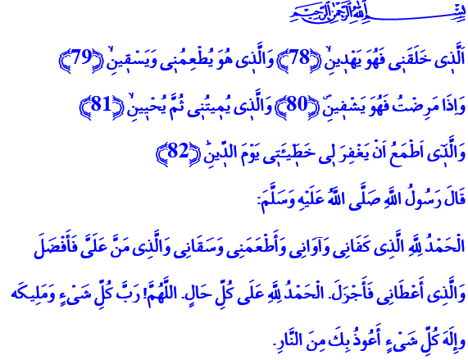
ALLAH IS THE ONE WHO CREATES, GIVES LIFE AND GUIDANCE
A Blessed Friday to You, Brothers and Sisters!
Despite all the efforts of our Prophet (pbuh), the pagans of Mecca did not abandon their false beliefs and their habits that did not fit within the boundaries of honor and dignity. They did not come to accept the belief in Tawheed, the fact that there is no god other than Allah. One day they came to our Prophet and said, “Tell us about your Lord!” After that, Our Almighty Lord has revealed the Surah Al-Ikhlas, which describes the faith of Tawheed in a concise way and introduces Himself to mankind in the most beautiful way:
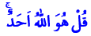 “Say: ‘He is Allah, the One and Only’”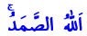 “God the Eternal, the Uncaused Cause of All Being.” 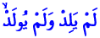 “He begets not, and neither is He begotten.” 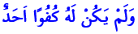 “And there is nothing that could be compared with Him”

Honorable Believers!
Our Book, Holy Qur'an, is a book that describes our Lord Allah to us from cover to cover. It is a handbook of guidance that teaches us to believe in Him, to surrender to Him, to worship Him; that shows us the ways towards a humane life and peace. Now I want to share with you in today’s khutba the verses of the Surah Ash-Shu’ara, which describes our Lord to us in the most beautiful way.
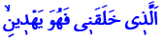
Venerable Believers!
Our Almighty Lord enjoins: That is to say, Our Lord is the creator and the guide. Through His prophets and books, He shows us the sirat al-mustaqim – the straight path. Our task is to be the followers of this path. It is to stay out of evil and to spread goodness on earth within our power.
Our Lord enjoins: 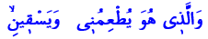 That is to say, Allah is the One who favors us each drop of the water we drink and each bite of the food we eat. Our task is to seek halal sustenance. It is not to forget that each blessing, each opportunity is entrusted to us by our Lord. It is to be able to see both wealth and poverty as a test. Just as our Prophet (pbuh) said, it is to be grateful by saying: “All praise and thanks be to Allah in all circumstances.”
Our Almighty Lord enjoins: 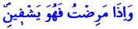 That is to say, Allah is the healer of illnesses. He blesses the suffering with remedies. He is the help to the helpless, hope to the hopeless. Our task is to never give the opportunity to those who want to exploit our beliefs, our sincerity, our feelings through our hardships and despair. It is to take refuge only in our Lord’s mercy. It is to place our trust in Him only. It is to endure illness and calamity with patience, fortitude and submission; knowing that they are trials for us.
Honorable Brothers and Sisters!
Our Lord enjoins: 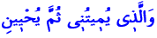 That is to say, Allah is the sole owner of life and death. He is the One who gives life, and who is going to take it when the time comes. Our Lord is going to revive us after we die. He is going to question us for our actions. He is going to give everyone what they exactly deserve. Our task is to stay true to our faith to the very last breath. It is to make our life blessed with righteous deeds. It is to be ready for death and the day of judgment at all times.
Allah wants us to hope for his mercy by enjoining:  Because He never lets down those who stay true to their faith, those who surrender to Him with all their heart. Our task is not to insist on sins and mistakes. It is to take refuge in our Lord’s name, At-Tawwab, with repentance that is the recognition of our helplessness and manifestation of our penitence. It is to pay no attention to those who promise us eternal salvation. It is to remember that our salvation depends only on the will of our Lord, with the guidance of Qur’an and as a result of a life that is lived under the teachings of our Prophet (pbuh).
Brothers and Sisters!
I want to conclude this khutba with the prayer taught to us in Surah Ash-Shu’ara through the mouth of Prophet Ibrahim: “O our Lord! Bestow wisdom on us, and join us with the righteous! Grant us an honorable mention in later generations! Place us among the inheritors of the Garden of Delight! Do not put us to shame on the Day when all shall be raised from the dead!”

Al-Ikhlas, 112/1-4.
Ash-Shu’ara, 26/78-82.
Abu Dawud, Good Manners and Form, 97, 98. Written by: General Directorate of Religious Services

